**ITA 121 Web Systems and Technologies I**

Activity 6 – Final Project Storyboard

Group No. **5**

Members :

* Cordez, Roland Joseph
* Moreno, Jansel Noah
* Viñas, Judah Paulo

Title of your website : **One Piece Anime Reviews Blog**

**STORY BOARD**

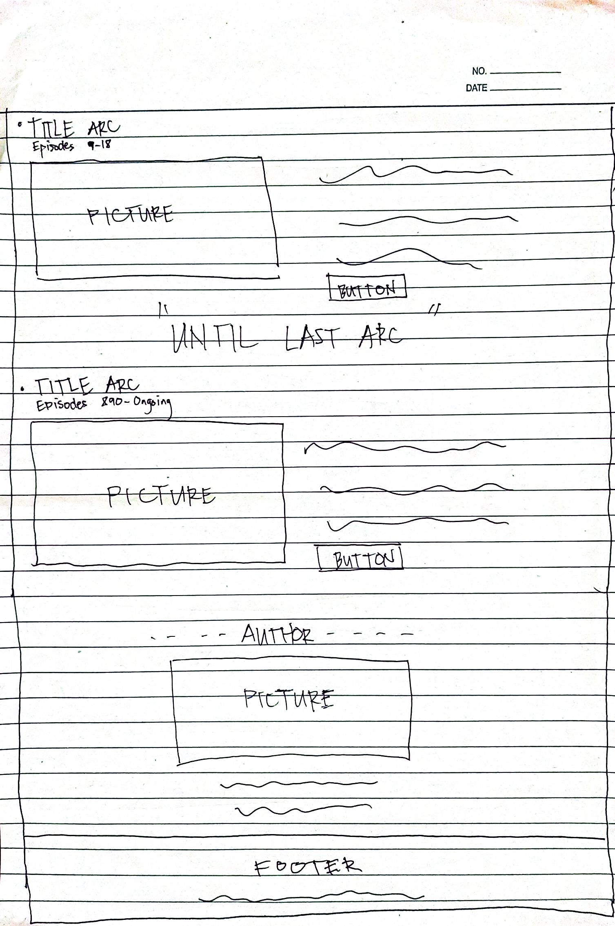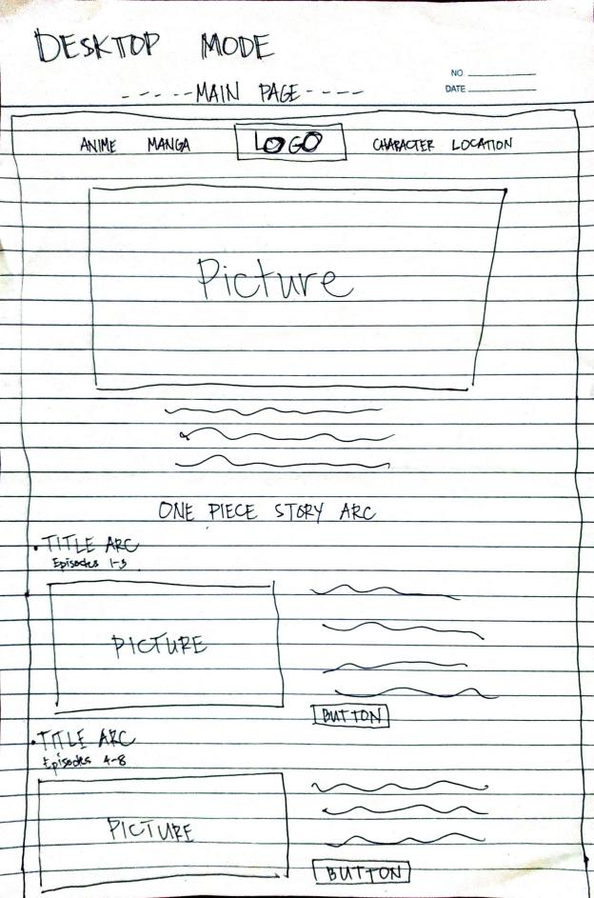

**NAVIGATION**

CHARACTER

MANGA

LOCATION

ANIME

**HOME**